Bainbridge Island/Kitsap County Resource List

Crisis Services

Bainbridge Island Police Department (BIPG), 206-842-5211 (Main line, general questions) Emergency: 911
- All officers have extra training in behavioral health crisis management
- Co-response unit – can request police transport to ER/Seattle Children’s
- Behavioral Health Outreach Program – LICSW, Kelsey Lynch

Kitsap Mental Health Services (KMH) – youth & adult programs, Medicaid, or private pay with LRO/LRA
(Less Restrictive Order/Alternative)
- www.kitsapmentalhealth.org
- Inpatient and Residential services, chemical dependency, WISe (wraparound intensive services) for kids and adults
- Crisis triage center (get referral from ER or Volunteers of America hotline)

Salish Behavioral Health Administrative Services Organization (SBH-ASO)
- https://www.kitsapgov.com/hs/Pages/SBHO-LANDING-HOME.aspx
- Mobile crisis unit
- Crisis line/Vol. of America hotline – can request dispatch for crisis responder to come out,
(888) 910-0416, 24/7 online crisis chat www.imhurting.org
- CLIP
- Connects people in crisis with services

Seattle Children’s Behavioral Health Crisis Care Clinic, https://www.seattlechildrens.org/clinics/psychiatry-and-behavioral-medicine/services/behavioral-health-crisis-care-clinic/

Kitsap Sexual Assault Center
- Free services, office on Bainbridge
- 24 hr hotline 866-831-2050 (ksacservices.com)
- Counseling, help with exams, court, etc.

Domestic Violence
- YWCA, http://ywcakitsap.org/family-advocacy-services/

24/7 HOTLINE: 1-800-500-5513
- Kitsap sexual assault center, https://www.victimresources.org
Beverly van Santford, child and family advocate, beverly-advocate@ksacservices.org

Crisis Hotlines

Text START to 741741 crisistextline.org

Crisis Call Center (National, 24/7/365, all ages) Call 775-784-8090

OR Text “ANSWER” to 839863, http://crisiscallcenter.org/get-help-247/
Crisis Clinic of the Peninsulas (24 hours) 1-800-843-4793
24 hr King County Crisis line: 866-427-4747 (can ask for help using DBT coping skills) www.crisisconnections.org
NAMI TALK HOTLINE: 1-800-273-8255, https://www.nami.org/help
NAMI TEXT HOTLINE: to 24/7 Crisis Line text NAMI to 741741
National Crisis Line (Volunteers of America): 24/7 TOLL FREE Crisis 1‐888‐910‐0416
24/7 online crisis chat www.imhurting.org. You can request that a crisis responder to come to your home, will provide transportation if you need it.
Resources for Veterans in Crisis 1-800-273-8255 Press 1 or Text 838255

Crisis Hotlines for Youth

Boys Town National Crisis Hotline 1-800-448-3000, yourlifeyourvoice.org (teens only)

Teen Link (866-833-8546), confidential and anonymous helpline for youth under 21
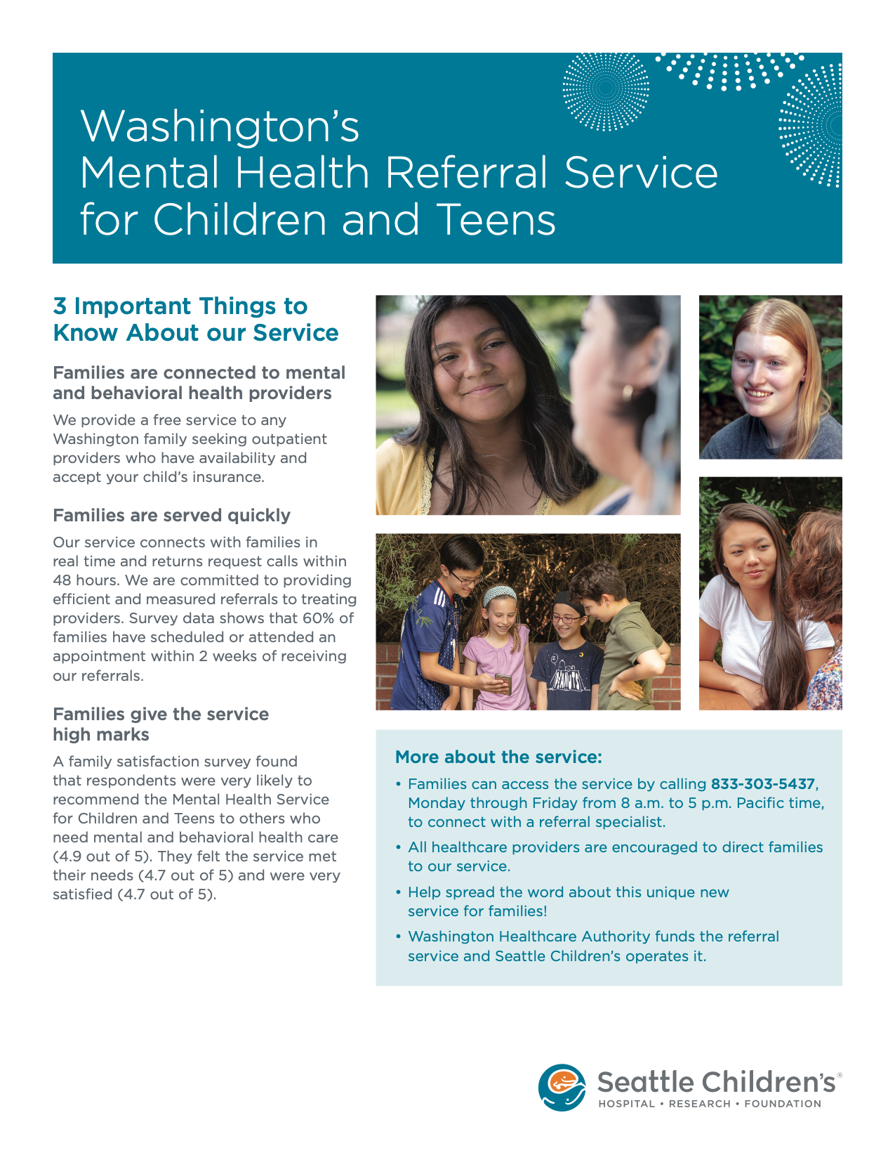
Coffee Oasis Text Line for youth ages 13-25 experiencing crisis 360-377-5560
The Trevor Project LGBTQ youth in crisis Call 1-866-488-7386 or Text START to 678678

Agencies and Resource Centers
- Kitsap County Human Services, https://www.kitsapgov.com/hs/Pages/Default%20Home%20Page%20HS.aspx
- Kitsap Mental Health Services, https://www.kitsapmentalhealth.org
- Salish Behavioral Health Administrative Services Organization (SBH-ASO), https://www.kitsapgov.com/hs/Pages/SBHO-LANDING-HOME.aspx
- Acadia Healthcare, Lesley Heathershaw (referral specialist) lesley.Heathershaw@acadiahealthcare.com
- Quartet Health Services, Referral Service associated with insurance coverage https://www.quartethealth.com
- Seattle Children’s Referral Service (free service):
833-303-5437 Mon-Friday 8am-5pm PST
- Bainbridge Island Resource Directory (BIRD), https://resourcedirectorybi.org

Addiction & Rehabilitation Services
- Cascade Behavioral Health – psychiatric and addiction rehabilitation for adults & geriatric, inpatient and outpatient services.
Seattle, WA – www.cascadebh.com – (206) 248-4787
- A Positive Alternative – counseling and support groups for adult men & women
Seattle, WA - https://www.apositivealternative.com
- Northpoint Washington – inpatient drug and alcohol rehabilitation facility in Edmonds, WA
https://www.northpointwashington.com
- Alcoholics Anonymous, https://www.aa.org
- SAMHSA – (National) Substance Abuse and Mental Health Services Administration https://www.samhsa.gov/find-help/national-helpline

Autism Evaluations & Resources:
- Hope Central - https://www.hopecentralhealth.org
- Seattle Children’s Hospital - https://www.seattlechildrens.org/clinics/autism-center/
- UW Medicine - https://depts.washington.edu/uwautism/

Senior Services:
- Kitsap County Aging and Long-term care - referral center and long-term care services, Silverdale & Poulsbo, Jennifer Calvin-Myers Program Supervisor jcmyers@co.kitsap.wa.us
www.agingkitsap.com, 360-337-5700 or 1-800-562-6418
- Island Volunteer Caregivers - https://www.ivcbainbridge.org
- Caring Transitions of Kitsap County – relocating, downsizing, estate sales, https://www.caringtransitionsop.com
- Bainbridge Island Senior/Community Center, https://biseniorcenter.org - Reed Price reed@biseniorcenter.org

Youth and Family Services:
- Bainbridge Youth Services, https://askbys.org
- Raising Resilience, https://www.raisingresilience.org
- Dean Doering and Associates, https://deandoering.com
- The Tyler Moniz Project, https://tylermonizproject.org/
- The Trevor Project, LGBTQ youth in crisis, https://www.thetrevorproject.org/?gclid=Cj0KCQiAlsv_BRDtARIsAHMGVSaTDpTmvoGXXRTTCWBBHoHtk_n65MrBh6yzDHtIuFyv9iRu4sy2vF8aAhBFEALw_wcB
- Peacock Family Services, https://peacockfamilyservices.org
- Gender Odyssey, http://www.genderodyssey.org

Housing, Food, Financial and Employment Assistance:
- Helpline House, https://www.helplinehouse.org
- Housing Resources Bainbridge, https://www.housingresourcesbi.org
- Housing Solutions Center, https://www.kcr.org/housing/
- Bainbridge Island Resource Directory (BIRD), https://resourcedirectorybi.org
- Skookum Contract Services (employment), https://www.skookum.org

School Mental Health Resources:
- Psychological First Aid for Schools (PFA), https://rems.ed.gov/K12PFAS.aspx
- Responding to COVID: School Mental Health
- https://mhttcnetwork.org/centers/global-mhttc/responding-covid-19-school-mental-health- resources
- AACAP School Resource Center
https://www.aacap.org/AACAP/Families_and_Youth/Resource_Centers/Schools_Resource_Ce nter/Home.aspx
- National Center for School Mental Health Sharon Hoover is amazing!
http://www.schoolmentalhealth.org/
- International Association for Child and Adolescent Psychiatry and Allied Professions
https://iacapap.org/
- Governor’s office of Education Ombuds – https://oeo.wa.gov/en, (866) 297-2597

Intensive Services – Inpatient, Outpatient, Residential, Intensive Outpatient and DBT programs
- Evidence Based Treatment Center of Seattle (EBTCS), adults & adolescents, https://ebtseattle.com/
- DBT Eastside, ages 11-18, http://www.dbteastside.com
- Thira Health, women & girls only, partial hospitalization program, https://thirahealth.com/programs/partial-hospitalization/
- Cadence Child & Adolescent Therapy, https://cadencechat.com
- Seattle Children’s, ages 13-17, https://www.seattlechildrens.org/clinics/psychiatry-and-behavioral-medicine/services/mood-and-anxiety-program/
- Ryther DBT Intensive Outpatient Program (IOP), ages 13-18, https://www.ryther.org/iop-dbt
- Imagine at Northpoint, ages 12-17, https://www.northpointwashington.com/imagine/
- The Emily Program, eating disorder focused, youth & adults, https://www.emilyprogram.com/locations/washington/
- Seattle Children’s OCD Intensive Outpatient Program, https://www.seattlechildrens.org/clinics/psychiatry-and-behavioral-medicine/services/obsessive-compulsive-disorder-intensive-outpatient-program/
- Seattle Children’s Hospital Inpatient Care, https://www.seattlechildrens.org/healthcare-professionals/access-services/inpatient-care/
- Fairfax Hospital, https://www.fairfaxhospital.com
- Swedish Hospital, https://www.swedish.org/services/behavioral-health/inpatient-services
- Mary Bridge Children’s Hospital, https://www.marybridge.org/services/inpatient-pediatric-service/
- Smokey Point Behavioral Hospital, https://www.smokeypointbehavioralhospital.com
- Kitsap Mental Health Inpatient and Residential Services, youth & adults with Medicaid, https://www.kitsapmentalhealth.org/get-help/adults-older-adults/inpatient-and-residential-services/
- Kitsap Mental Health Wraparound with Intensive Services, youth & adults with Medicaid, https://www.kitsapmentalhealth.org/get-help/children-youth-families/wise/

